Experiment 6

AIM:-
Implement Local Search algorithm for optimization : Genetic Algorithm

THEORY:-
Local search in AI refers to a family of optimization algorithms that are used to find the best possible solution within a given search space. Unlike global search methods that explore the entire solution space, local search algorithms focus on making incremental changes to improve a current solution until they reach a locally optimal or satisfactory solution.

The basic working principle of a local search algorithm involves the following steps:
- Initialization
- Evaluation
- Neighbor Generation
- Selection
- Termination

Genetic Algorithm-
A genetic algorithm is an adaptive heuristic search algorithm inspired by "Darwin's theory of evolution in Nature." It is used to solve optimization problems in machine learning. It is one of the important algorithms as it helps solve complex problems that would take a long time to solve.
Genetic Algorithms are being widely used in different real-world applications, for example, Designing electronic circuits, code-breaking, image processing, and artificial creativity. A genetic algorithm is a heuristic search algorithm to solve optimization problems. It is a subset of evolutionary algorithms, which is used in computing. A genetic algorithm uses genetic and natural selection concepts to solve optimization problems. Applications of Genetic Algorithms include Recurrent Neural Network, Mutation testing, Code breaking, Filtering and signal processing, Learning fuzzy rule base, etc

Basic terminologies in the Genetic algorithm:
- Population: Population is the subset of all possible or probable solutions, which can solve the given problem.
- Chromosomes: A chromosome is one of the solutions in the population for the given problem, and the collection of gene generate a chromosome.
- Gene: A chromosome is divided into a different gene, or it is an element of the chromosome.
- Fitness Function: The fitness function is used to determine the individual's fitness level in the population. It means the ability of an individual to compete with other individuals. In every iteration, individuals are evaluated based on their fitness function.
- Genetic Operators: In a genetic algorithm, the best individual mate to regenerate offspring better than parents. Here genetic operators play a role in changing the genetic composition of the next generation.
- Selection: After calculating the fitness of every existent in the population, a selection process is used to determine which of the individualities in the population will get to reproduce and produce the seed that will form the coming generation.

The genetic algorithm works on the evolutionary generational cycle to generate high-quality solutions. It basically involves five phases to solve the complex optimization problems, which are given as below:
1. Initialization
The process of a genetic algorithm starts by generating the set of individuals, which is called population. Here each individual is the solution for the given problem. An individual contains or is characterized by a set of parameters called Genes. Genes are combined into a string and generate chromosomes, which is the solution to the problem. One of the most popular techniques for initialization is the use of random binary strings.

2. Fitness Assignment
Fitness function is used to determine how fit an individual is. It means the ability of an individual to compete with other individuals. In every iteration, individuals are evaluated based on their fitness function. The fitness function provides a fitness score to each individual. The high the fitness score, the more chances of getting selected for reproduction.
3. Selection
The selection phase involves the selection of individuals for the reproduction of offspring. All the selected individuals are then arranged in a pair of two to increase reproduction. Then these individuals transfer their genes to the next generation.
There are three types of Selection methods available, which are:
- Roulette wheel selection
- Tournament selection
- Rank-based selection

4. Reproduction
After the selection process, the creation of a child occurs in the reproduction step. In this step, the genetic algorithm uses two variation operators that are applied to the parent population. The two operators involved in the reproduction phase are:

- Crossover: In this process, a crossover point is selected at random within the genes. Then the crossover operator swaps genetic information of two parents from the current generation to produce a new individual representing the offspring until the crossover point is met. This process is also called crossover. Types of crossover styles available:
  - One point crossover
  - Two-point crossover
  - Livery crossover
  - Inheritable Algorithms crossover

- Mutation: The mutation operator inserts random genes in the offspring to maintain the diversity in the population. It can be done by flipping some bits in the chromosomes. Mutation helps in solving the issue of premature convergence and enhances diversification.
Types of mutation styles available:
  - Flip bit mutation
  - Gaussian mutation
  - Exchange/Swap mutation
5. Termination
After the reproduction phase, a stopping criterion is applied as a base for termination. The algorithm terminates after the threshold fitness solution is reached. It will identify the final solution as the best solution in the population.
General Workflow of a Simple Genetic Algorithm-
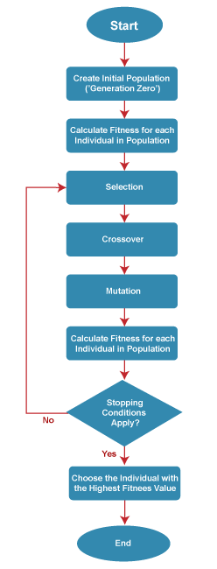

Advantages of Genetic Algorithm
- The parallel capabilities of genetic algorithms are best.
- It helps in optimizing various problems such as discrete functions, multi-objective problems, and continuous functions.
- It provides a solution for a problem that improves over time.
- A genetic algorithm does not need derivative information.
Limitations of Genetic Algorithms
- Genetic algorithms are not efficient algorithms for solving simple problems.
- It does not guarantee the quality of the final solution to a problem.
- Repetitive calculation of fitness values may generate some computational challenges.

Code:-
import random

def fitness(chromosome):
return sum(chromosome)

def create_individual(length, min_value, max_value):
return [random.randint(min_value, max_value) for _ in range(length)]

def create_population(population_size, chromosome_length, min_value, max_value):
return [create_individual(chromosome_length, min_value, max_value) for _ in range(population_size)]

def selection(population, fitness_values, tournament_size):
selected_parents = []
for _ in range(len(population)):
tournament = random.sample(range(len(population)), tournament_size)
winner = tournament[0]
for challenger in tournament[1:]:
if fitness_values[challenger] > fitness_values[winner]:
winner = challenger
selected_parents.append(population[winner])
return selected_parents

def crossover(parent1, parent2):
crossover_point = random.randint(1, len(parent1) - 1)
child1 = parent1[:crossover_point] + parent2[crossover_point:]
child2 = parent2[:crossover_point] + parent1[crossover_point:]
return child1, child2

def mutation(chromosome, mutation_rate, min_value, max_value):
mutated_chromosome = []
for gene in chromosome:
if random.random() < mutation_rate:
mutated_chromosome.append(random.randint(min_value, max_value))
else:
mutated_chromosome.append(gene)
return mutated_chromosome

def evolve(population, mutation_rate, tournament_size):
fitness_values = [fitness(chromosome) for chromosome in population]

selected_parents = selection(population, fitness_values, tournament_size)

offspring = []
for i in range(0, len(selected_parents), 2):
parent1 = selected_parents[i]
parent2 = selected_parents[i + 1]
child1, child2 = crossover(parent1, parent2)
offspring.append(child1)
offspring.append(child2)

mutated_offspring = [mutation(chromosome, mutation_rate, min_value, max_value) for chromosome in offspring]

return mutated_offspring

def get_user_input():
population_size = int(input("Enter population size: "))
chromosome_length = int(input("Enter chromosome length: "))
min_value = int(input("Enter minimum value for genes: "))
max_value = int(input("Enter maximum value for genes: "))
mutation_rate = float(input("Enter mutation rate (between 0 and 1): "))
tournament_size = int(input("Enter tournament size: "))
generations = int(input("Enter number of generations: "))
return population_size, chromosome_length, min_value, max_value, mutation_rate, tournament_size, generations
if __name__ == "__main__":

population_size, chromosome_length, min_value, max_value, mutation_rate, tournament_size, generations = get_user_input()
population = create_population(population_size, chromosome_length, min_value, max_value)

for generation in range(generations):
population = evolve(population, mutation_rate, tournament_size)

print("Final Population:")
for individual in population:
print(individual, "Fitness:", fitness(individual))

Output:-
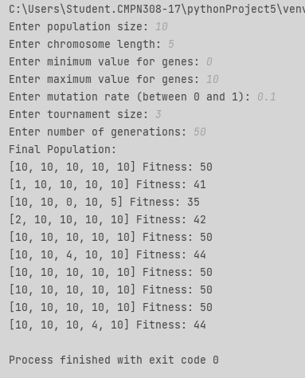

CONCLUSION:-
Genetic algorithm (GA) is a heuristic search and optimization technique inspired by the principles of natural selection and evolution. It operates by maintaining a population of potential solutions to a problem and iteratively improving these solutions over generations. Each solution is represented as a chromosome composed of genes encoding parameters of the problem. Through processes like selection, crossover, and mutation, the GA evolves the population towards better solutions. Fitness evaluation guides the selection of individuals for reproduction, ensuring that better-performing solutions have a higher chance of being passed on to the next generation.

